BIOL 222

Exam 3

1) What does the operon model attempt to explain?

A) the coordinated control of gene expression in bacteria
B) bacterial resistance to antibiotics
C) how genes move between homologous regions of DNA
D) the mechanism of viral attachment to a host cell
E) horizontal transmission of plant viruses

2) Which enzyme catalyzes the elongation of a DNA strand in the 5' → 3' direction?

A) primase
B) DNA ligase
C) DNA polymerase III
D) topoisomerase
E) helicase

3) Long distance signaling is…

A) paracrine signaling
B) exocrine signaling
C) neurotransmitter signaling
D) hormonal (endocrine) signaling
E) smoke signaling

4) A small molecule that specifically binds to another molecule, usually a larger one

A) is called a signal transducer
B) is called a ligand
C) is called a polymer
D) seldom is involved in hormonal signaling
E) usually terminates a signal reception

5) The phenomenon in which RNA molecules in a cell are destroyed if they have a sequence complementary to a double-stranded RNA is called

A) RNA interference
B) RNA obstruction
C) RNA blocking
D) RNA targeting
6) DNA methylation, and histone acetylation are examples of

A) genetic mutation
B) chromosomal rearrangements
C) karyotypes
D) epigenetics
E) translocation

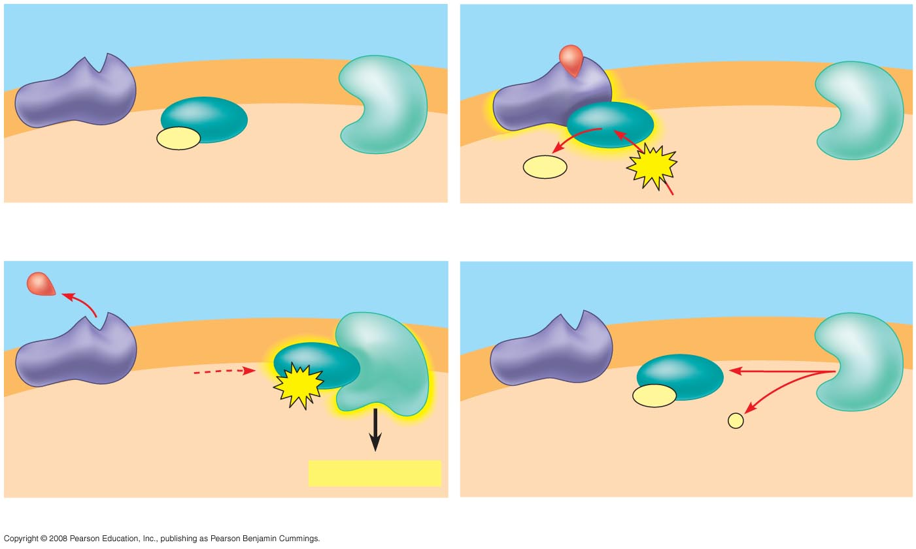

2
1
5
4

3

Using the image above, answer the following 4 Questions.

7) Which is the G-coupled protein receptor with a ligand bound?

A) 1

B) 2

C) 3

D) 4

E) 5

8) Which is the G protein?

A) 1

B) 2

C) 3

D) 4

E) 5

9) Which is the energy molecule GTP?

A) 1

B) 2

C) 3

D) 4

E) 5

10) Which is the activated enzyme?

A) 1

B) 2

C) 3

D) 4

E) 5

Use the genetic code table at the end of this exam for question 11.

11) What amino acid sequence will be generated, based on the following mRNA codon sequence?
5' AUG-UCU-UCG-UUA-UCC-UUG 3'

A) met-arg-glu-arg-glu-arg
B) met-glu-arg-arg-gln-leu
C) met-ser-leu-ser-leu-ser
D) met-ser-ser-leu-ser-leu
E) met-leu-phe-arg-glu-glu

12) What is the sequence of a peptide based on the following DNA sequence?
3' . . . AAAAGAATAACAGAA 5'

A) leu-cys-tyr-ser-phe
B) cyc-phe-tyr-cys-leu
C) phe-leu-ile-met-val
D) leu-pro-asp-lys-gly
E) phe-ser-tyr-cys-leu

13) The tryptophan operon is a repressible operon that is

A) permanently turned on
B) turned on only when tryptophan is present
C) turned off only when glucose is present
D) turned on only when glucose is present
E) turned off whenever tryptophan is present

14) When this is taken up by the cell, it binds to the repressor so that the repressor no
longer binds to the operator:

A) operon
B) inducer
C) promoter
D) repressor
E) corepressor

15) What determines the nucleotide sequence of the newly synthesized strand during DNA replication?

A) the particular DNA polymerase catalyzing the reaction
B) the relative amounts of the four nucleoside triphosphates in the cell
C) the nucleotide sequence of the template strand
D) the primase used in the reaction
E) the arrangement of histones in the sugar phosphate backbone

16) Which of the following help(s) to stabilize mRNA by inhibiting its degradation in the cytosol?
A) TATA box
B) spliceosomes
C) 5' cap and poly (A) tail
D) introns
E) RNA polymerase

17) This type of plasma membrane receptor is capable of activating several intracellular pathways at once.

A) receptor tyrosine kinase
B) G-protein coupled receptor
C) ligand gated ion channel
D) aquaporin protein

18) This binds to a site in the DNA far from the promoter to stimulate transcription:
A) enhancer
B) promoter
C) activator
D) repressor
E) terminator

19) At a specific area of a chromosome, the sequence of nucleotides below is present where the chain opens to form a replication fork:
3' C C T A G G C T G C A A T C C 5'
An RNA primer is formed starting at the underlined T (T) of the template. Which of the following represents the primer sequence?

A) 5' G C C T A G G 3'
B) 3' G C C T A G G 5'
C) 5' A C G T T A G G 3'
D) 5' A C G U U A G G 3'
E) 5' G C C U A G G 3'

20) What are the coding segments of a stretch of eukaryotic DNA called?

A) introns
B) exons
C) codons
D) replicons
E) transposons

21) A post synaptic gated sodium channel on a neuron would be what general type of cell membrane receptor?

A) G-protein coupled
B) Ligand-gated ion channel
C) Ion pump
D) Receptor-tyrosine kinase

22) To repair a thymine dimer by nucleotide excision repair, in which order do the necessary enzymes act?

A) exonuclease, DNA polymerase III, RNA primase
B) helicase, DNA polymerase I, DNA ligase
C) DNA ligase, nuclease, helicase
D) DNA polymerase I, DNA polymerase III, DNA ligase
E) endonuclease, DNA polymerase I, DNA ligase

23) A mutation that inactivates the regulatory gene of a repressible operon in an E. coli cell would result in

A) continuous transcription of the gene controlled by that regulator
B) complete inhibition of transcription of the gene controlled by that regulator
C) irreversible binding of the repressor to the operator
D) inactivation of RNA polymerase by alteration of its active site
E) continuous translation of the mRNA because of alteration of its structure

24) This can inhibit transcription by blocking the binding of transcription factors to the DNA:

A) enhancer
B) promoter
C) activator
D) repressor
E) terminator

25) Which of the following experimental procedures is most likely to hasten mRNA degradation in a eukaryotic cell?

A) enzymatic shortening of the poly(A) tail
B) inclusion of introns
C) methylation of C nucleotides
D) methylation of histones
E) removal of one or more exons

26) Paracrine signaling

A) involves secreting cells acting on nearby target cells by discharging a local regulator into the extracellular fluid
B) requires nerve cells to release a neurotransmitter into the synapse
C) occurs only in paracrine yeast cells
D) has been found in plants but not animals

27) Alternative RNA splicing

A) is a mechanism for increasing the rate of transcription
B) can allow the production of different proteins from a single RNA primary transcript
C) can allow the production of the same proteins from different RNAs
D) increases the rate of transcription

28) What is the function of topoisomerase?

A) to nick one strand of the DNA to allow 360 degree rotation to alleviate the over twisting created by helicase activity
B) the attachment of complimentary DNA nucleotides during DNA replication
C) to unwind and unzip the DNA double helix
D) repair of the sugar phosphate backbone by the reattachment of the sugar of one nucleotide to the phosphate of the next nucleotide
E) Proofreading of the newly synthesized DNA strand to identify mismatched bases

29) How does active CAP induce expression of the genes of the lactose operon?

A) It terminates production of repressor molecules
B) It degrades the substrate allolactose
C) It stimulates the binding of RNA polymerase to the promoter
D) It binds steroid hormones and controls translation

30) From the perspective of the cell receiving the message, the three stages of cell signaling are

A) the paracrine, local, and synaptic stages
B) signal reception, signal transduction, and cellular response
C) signal reception, nucleus disintegration, and new cell generation
D) the alpha, beta, and gamma stages
E) signal reception, cellular response, and cell division

31) A particular triplet of bases in the coding sequence of a DNA template is AAA. The anticodon on the tRNA that binds the mRNA codon is

A) TTT
B) UUA
C) UUU
D) AAA

32) Which of the following separates the DNA strands during replication?

A) helicase
B) DNA polymerase III
C) ligase
D) DNA polymerase I
E) primase

33) Which is an example of a secondary messenger?

A) cAMP
B) G protein
C) Hormone
D) Neurotransmitter

34) Which is the first event in translation in eukaryotes?

A) elongation of the polypeptide
B) base pairing of activated methionine-tRNA to AUG (start codon) of the messenger RNA
C) the larger ribosomal subunit binds to smaller ribosomal subunits
D) covalent bonding between the first two amino acids
E) the small subunit of the ribosome recognizes and attaches to the 5' cap of mRNA

35) The leading and the lagging strands differ in that

A) the leading strand is synthesized in the same direction as the movement of the replication fork, and the lagging strand is synthesized in the opposite direction
B) the leading strand is synthesized by adding nucleotides to the 3' end of the growing strand, and the lagging strand is synthesized by adding nucleotides to the 5' end
C) the lagging strand is synthesized continuously, whereas the leading strand is synthesized in short fragments that are ultimately stitched together
D) the leading strand is synthesized at twice the rate of the lagging strand

36) Muscle cells and nerve cells in one organism owe their differences in structure to

A) having different genes
B) having different chromosomes
C) using different genetic codes
D) having different genes expressed
E) having unique ribosomes

37) As a ribosome translocates along an mRNA molecule by one codon, which of the following occurs?

A) The tRNA that was in the A site moves into the P site
B) The tRNA that was in the P site moves into the A site
C) The tRNA that was in the A site moves to the E site and is released
D) The tRNA that was in the A site departs from the ribosome via the polypeptide tunnel

38) Which of the following best describes the addition of nucleotides to a growing DNA chain?

A) A nucleoside triphosphate is added to the 5' end of the DNA, releasing a molecule of pyrophosphate
B) A nucleoside triphosphate is added to the 3' end of the DNA, releasing a molecule of pyrophosphate
C) A nucleoside diphosphate is added to the 5' end of the DNA, releasing a molecule of phosphate
D) A nucleoside diphosphate is added to the 3' end of the DNA, releasing a molecule of phosphate
E) A nucleoside monophosphate is added to the 5' end of the DNA

39) Which of the following helps to hold the DNA strands apart while they are being replicated?

A) primase
B) ligase
C) DNA polymerase
D) single-strand binding proteins
E) exonuclease

40) A frameshift mutation could result from

A) a base insertion only
B) a base deletion only
C) a base substitution only
D) deletion of three consecutive bases
E) either an insertion or a deletion of a base

41) Cytosine makes up 38% of the nucleotides in a sample of DNA from an organism. Approximately what percentage of the nucleotides in this sample will be thymine?

A) 12
B) 24
C) 31
D) 38
E) It cannot be determined from the information provided.

42) Which of the following is true for both prokaryotic and eukaryotic gene expression?

A) After transcription, a 3' poly-A tail and a 5' cap are added to mRNA
B) Translation of mRNA can begin before transcription is complete
C) RNA polymerase binds to the promoter region to begin transcription
D) mRNA is synthesized in the 3' → 5' direction

43) Why does the DNA double helix have a uniform diameter?

A) Purines pair with pyrimidines
B) C nucleotides pair with A nucleotides
C) Deoxyribose sugars bind with ribose sugars
D) Nucleotides bind with nucleosides

44) In which of the following actions does RNA polymerase differ from DNA polymerase?

A) RNA polymerase uses RNA as a template, and DNA polymerase uses a DNA template
B) RNA polymerase binds to single-stranded DNA, and DNA polymerase binds to double-stranded DNA
C) RNA polymerase is much more accurate than DNA polymerase
D) RNA polymerase can initiate RNA synthesis, but DNA polymerase requires a primer to initiate DNA synthesis

45) RNA polymerase moves in which direction along the DNA?

A) 3' → 5' along the template strand
B) 5' → 3' along the template strand
C) 3' → 5' along the non-template strand
D) 5' → 3' along the non-template strand

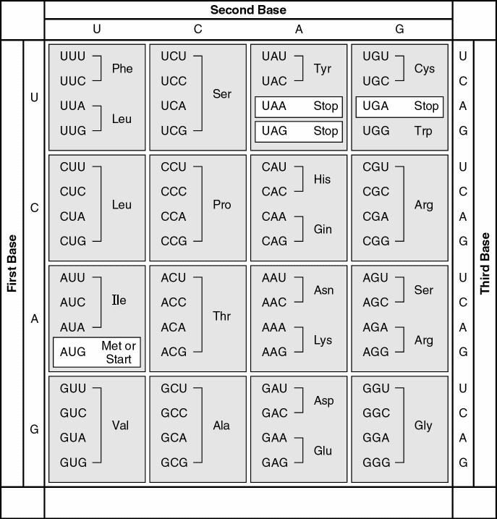

ESSAY:

On a separate sheet of paper choose and answer only two of the following…
(5pts ea.)

1. Using the following eukaryotic DNA sequence (introns are bracketed – [xxxxxx]) show the primary transcript, final mRNA (with cap and tail), sequential tRNA anticodons, and final resulting amino acid sequence (using the genetic code above)

3’-TACACCTTG[GCAAAGCAT]GTGACCGGACAT[TGTACC]CCTTACACT–5’

2. Diagram a DNA replication bubble and label it using the following terms wherever appropriate (may be used more than once):

helicase, topoisomerase, 5’, 3’, DNA polymerase, ligase, replication fork, leading strand, lagging strand, single strand binding protein, origin of replication, Okazaki fragment, primase, RNA primer, parent DNA strand.

3. Diagram a primary messenger reaching its target cell and show how the message gets transduced into the cell and activates a second messenger. Include each step of the process and provide an example of the second messenger that may be used.

4. Describe the function of the enzyme telomerase in terms of where (cell type) it is active and the job it performs. Describe what you think might happen to a familial line if the gene that codes for telomerase were to become mutated rendering it non-functional in those cells where it is normally active.

BONUS! (2pts)

What is meant when I refer to the redundancy of the genetic code?

