Kidney Dissection

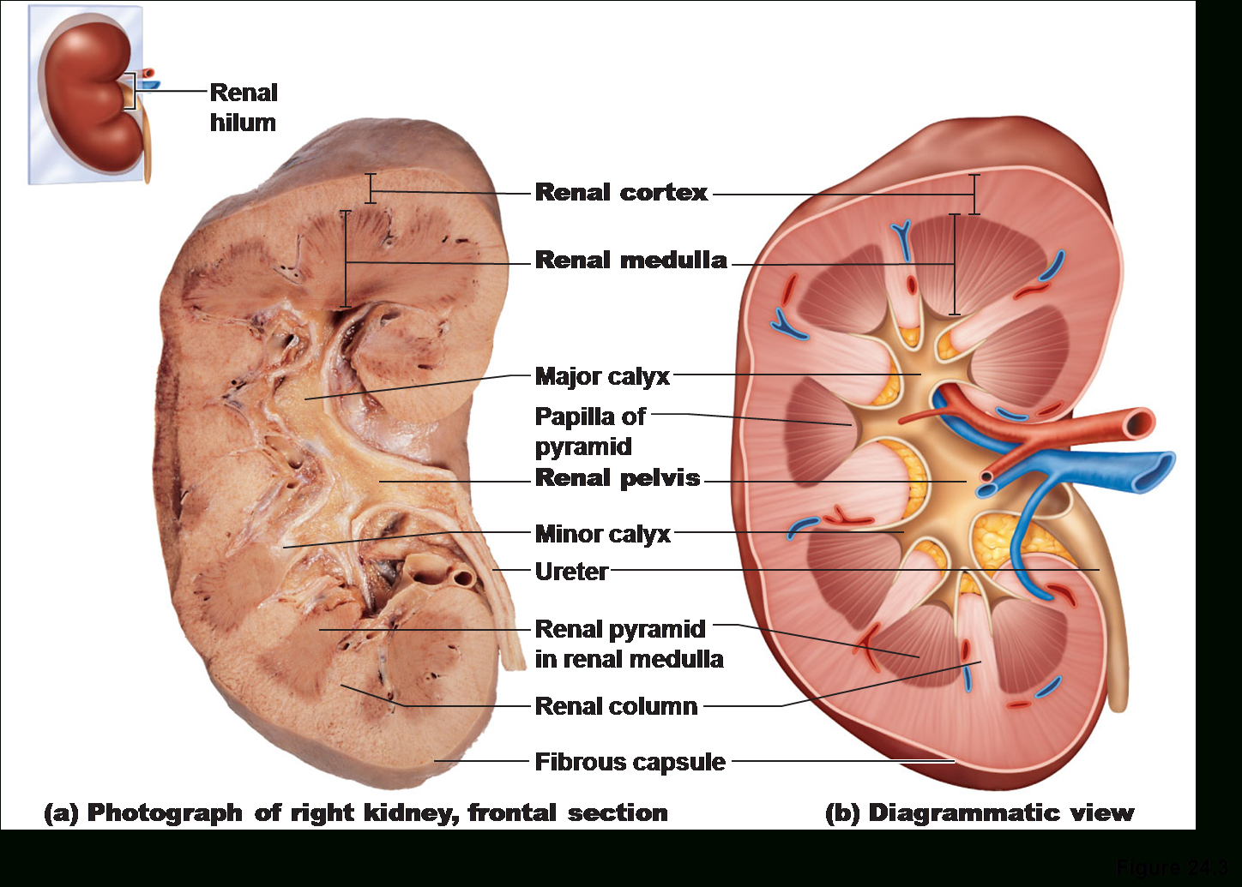

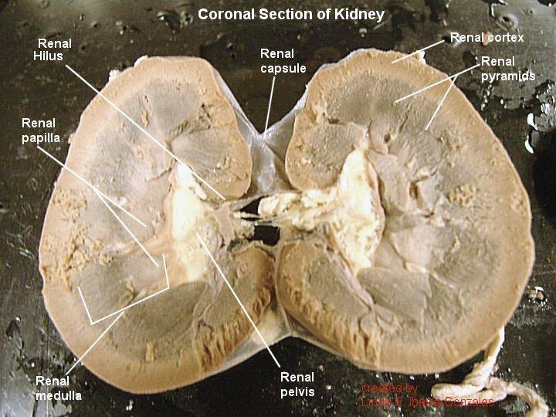

Kidney Structures to know:
Hilus
Renal pelvis
Renal cortex
Renal medulla
Medullary pyramid
Major calyx (calyces)
Minor calyx (calyces)

